Design and Implementation of 2:1 Multiplexer
Objective:
A multiplexer which means that n number of inputs and only one output. It can take many inputs and find the output using the selector to select perfect output for the circuit. In 2:1 mux means 2 input with one selector and find the 1 output.

Theory:
The expression may as:
Y=S’A+SB
Where, the input is A, B and One Seletor is used as S and the output is only one value is Y. That may find the value of on and off.
The Table can be written as:
A | B | S | Y
0 | 0 | 0 | 0
0 | 0 | 1 | 0
0 | 1 | 0 | 0
0 | 1 | 1 | 1
1 | 0 | 0 | 1
1 | 0 | 1 | 0
1 | 1 | 0 | 1
1 | 1 | 1 | 1

2:1 Muliplexer
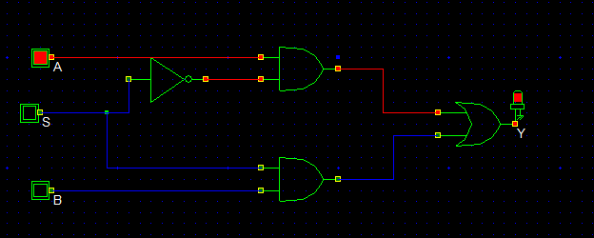
Circuit Diagram If all input is 0,selector is 0 then output will be as
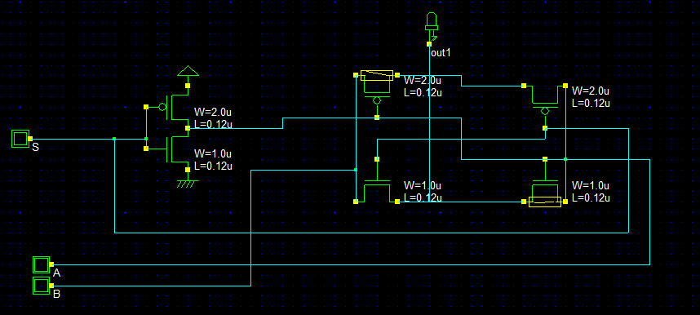
If input A and B is 1 and selector is 0, then the light in on state….
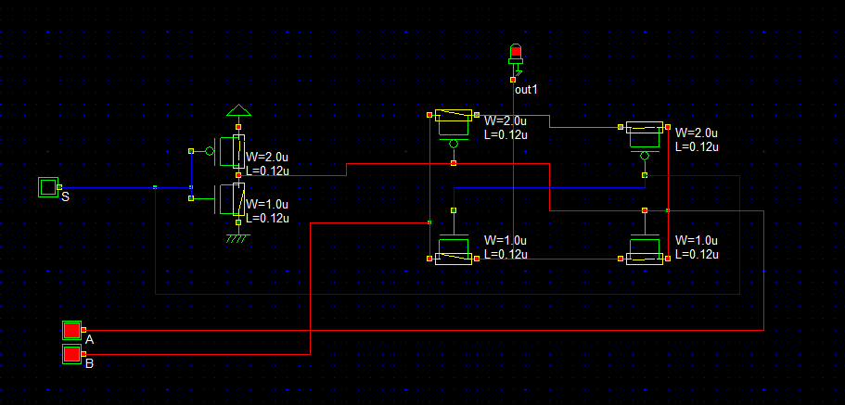
Verilog File
// DSCH 2.6h
// 11/8/2018 10:21:21 PM
// D:\BOOK\sem 4-1\VLSI\Lab\microwind\multiplex.sch

module multiplex( S,A,B,out1);
input S,A,B;
output out1;
pmos #(45) pmos(A,vdd,S); // 2.0u 0.12u
nmos #(45) nmos(A,vss,S); // 1.0u 0.12u
pmos #(10) pmos(w4,B,A); // 2.0u 0.12u
pmos #(45) pmos(A,w4,S); // 2.0u 0.12u
nmos #(17) nmos(B,out1,S); // 1.0u 0.12u
nmos #(17) nmos(out1,A,A); // 1.0u 0.12u
endmodule
// Simulation parameters in Verilog Format
always
#1000 S=~S;
#2000 A=~A;
#3000 B=~B;
// Simulation parameters
// S CLK 10 10
// A CLK 20 20
// B CLK 30 30
Layout Diagram

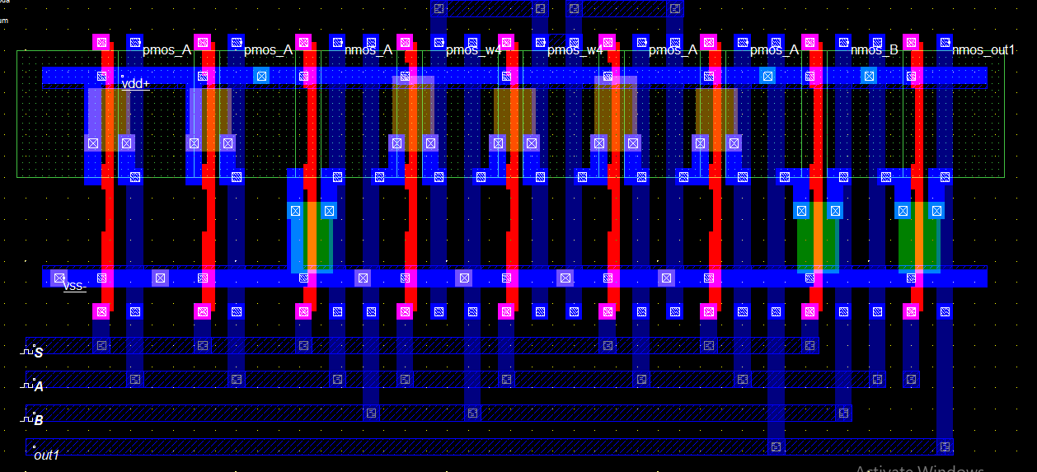

Timing Diagram

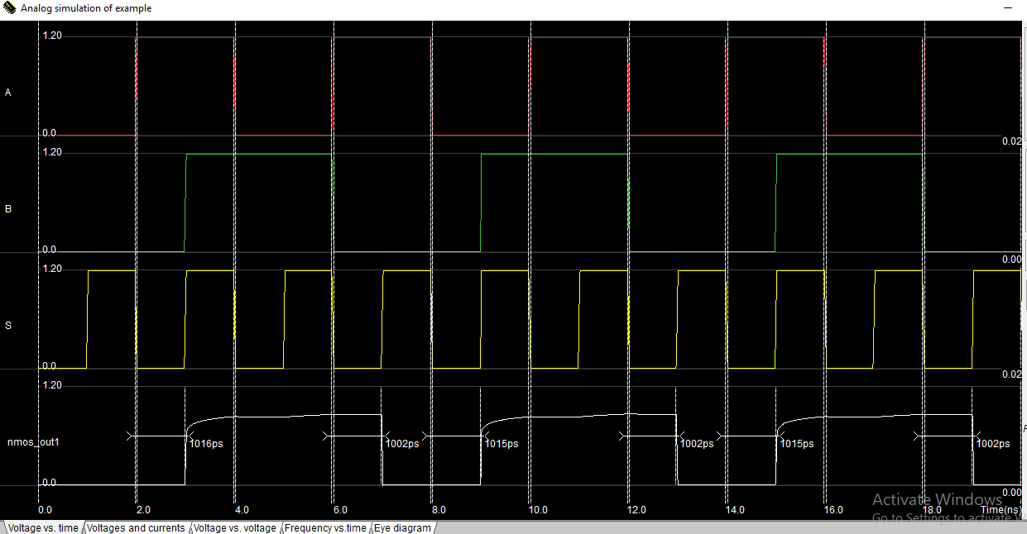

Stick Diagram

Timing Diagram
Discussion
From this 2:1mux implementation, we can easily find the different type of expression. It can help us to find the different equation problem solving and find only one perfect output.

